Project Background
The national Live Longer Better programme is supported by Sport England and delivered by Active Partnerships. Here in Cumbria, we aim to encourage older adults to take part in activities that challenge the body, brain, and mind. This will help prevent loss of fitness or regain fitness that has been lost due to inactivity and ill health. We have further information on our website: https://www.activecumbria.org/behealthybeactive/live-longer-better/
We are fortunate in Cumbria to have secured some financial resource to support our aims, which is available through the Reconditioning Fund.

About The Hiking Household
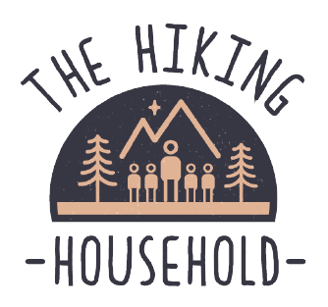
The Hiking Household is designed to be a go-to guide for families of all abilities who are keen to get outside with their brood! We offer easy to follow routes here in Cumbria, whether you are local to the area, or visiting on holiday, we have something for all ages and abilities to enjoy. The Hiking Household also produces easy to read resources to help people of all ages engage with their local outdoor areas. They have collaborated with many local organisations to produce various maps, adventure trails, orienteering courses and much more.

Reconditioning Fund Project Summary
The Hiking Household have developed a series of 6 trail maps led by Sir Muir Gray to enable people to live longer better, reduce the need for health and social care and reverse the effects of lockdown.
Each of the maps are easy to access, with regular bus routes available. They offer a range of routes from short to slightly longer, as well as a mixture of terrains. Some of the walks are pram and wheelchair accessible, others require appropriate footwear to manage the mixed terrain. There are multiple places to stop, rest and take in the scenery along the routes. All of the maps highlight benches, and other rest areas, as well as offering ideas on how to improve your physical and mental health through getting outside.

Monitoring & Evaluation
In the absence of an identified cohort of older adults to take ‘start’ and ‘end’ data from in relation to use of the maps, the decision was made to monitor and evaluate the quantitative data available through engagement with the launch events, social media data analysis and website analytics. 200 hard copies of each map were printed and distributed in total, available from local assets proximal to the walk routes.

Launch events
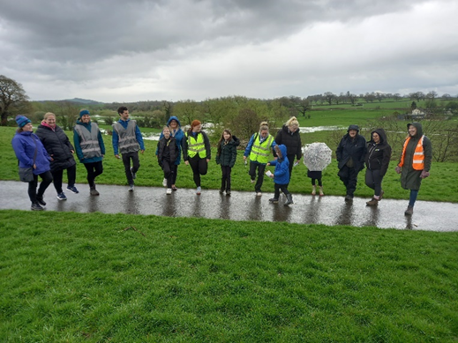
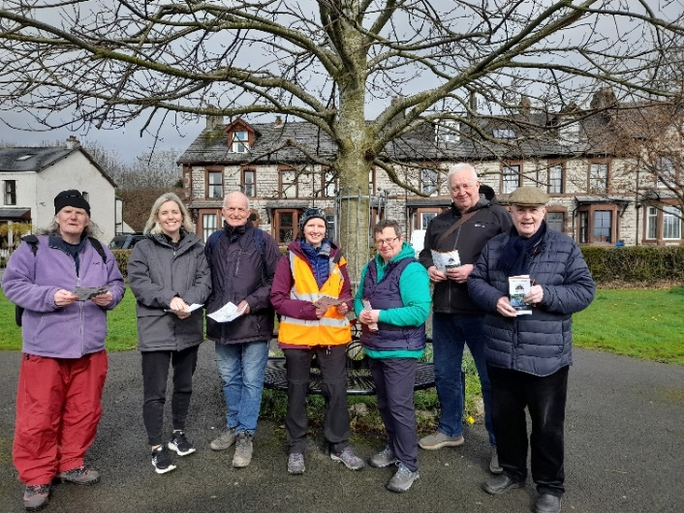
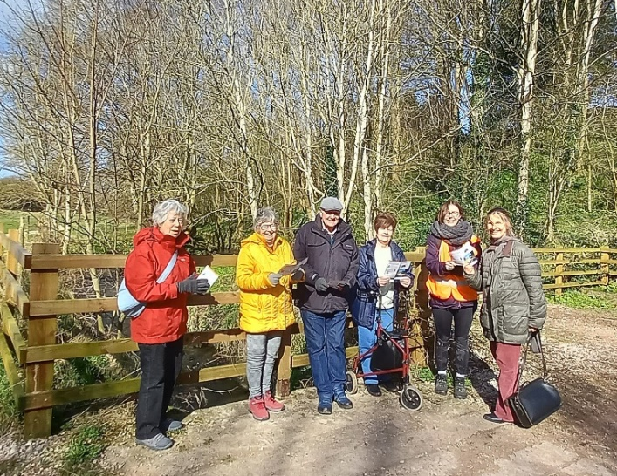
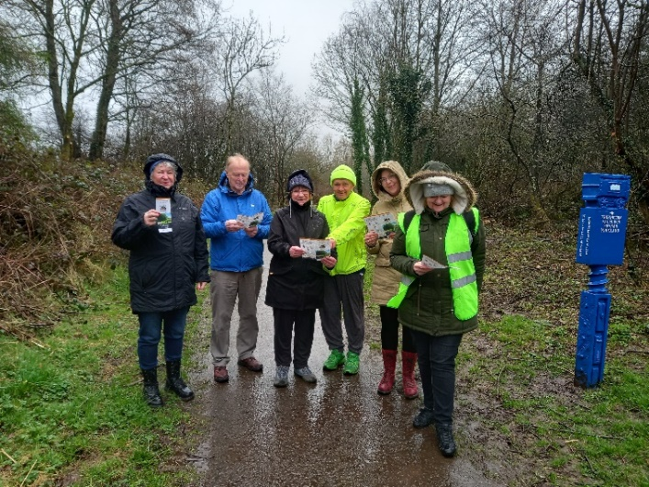
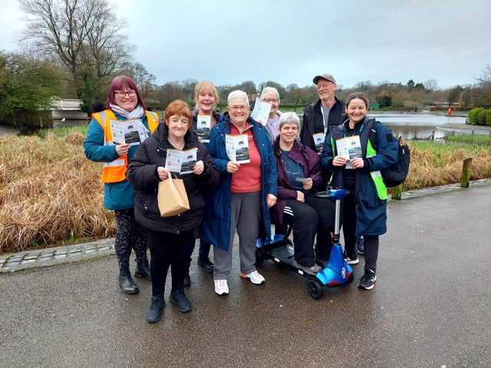
Pictured – Barrow Park, Cleator Moor, Pategill, Lightburn Park, Petteril Valley and Vulcan’s Park.
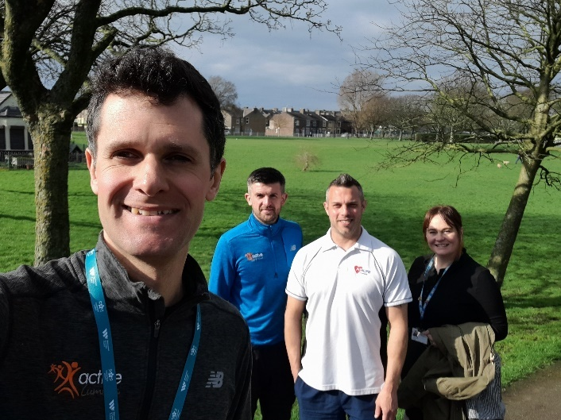

Social media analysis
Totals from first launch event 03/03/24 to final launch event 10/04/2024
Facebook |  |  |  | Instagram |  |  | Twitter
Reach | Reaction | Comments | Shares | Reach | Likes | Comments | Impressions | Engagements | Link Clicks
10705 | 205 | 13 | 0 | 1018 | 49 | 7 | 679 | 36 | 0

Website analytics
The maps are available to download from the Active Cumbria website as well as the Hiking Household website. They are available in hard copy in locations proximal to each of the walk sites.
From the Active Cumbria website downloads total:
• Pategill Map, Penrith - 426
• Petteril Valley Map, Carlisle - 344
• Lightburn Park Map, Ulverston - 404
• Vulvan Park Map, Workington - 280
• Barrow Park Map, Barrow - 419
• The Whitehaven to Ennerdale cycle path, Cleator Moor - 273
From the Hiking Household website, downloads total 924 for all 6 maps – therefore total downloads from both websites is 3,070 in the period from launch in April 2024 to December 2024.

Impact
Reach and engagement with the social media posts and websites demonstrate a good level of interest in the maps as resources for older adults and those that support them.
The following Live Longer Better in Cumbria aims have been achieved:
- Increase physical ability and movement, resilience and healthspan, and to prevent falls and frailty
- Reduce the risk of, and delay or prevent dementia
- Empower Older Adults to counteract the detrimental effects of ageism (the stereotypes (how we think), prejudice (how we feel) and discrimination (how we act) towards others or oneself based on age)
- Prevent and mitigate isolation

Next steps/future plans
The Hiking Household has secured investment from the Travel Actively Fund to create similar maps to engage the target audience for that fund in active travel in both Carlisle and Barrow.
A further resource is under development to allow Older Adults to add strength, balance and mindfulness activities to their walks regardless of where that walk might be. This has been initiated from feedback from map users that it would be helpful to have a generic resource that is not restricted to certain parks/places. This will then be available to all Ramblers Wellbeing Walk leaders as well as other partners and providers across the county.

For further information on this project please contact:
Aileen Grant
| Active Cumbria | Public Health & Communities | Cumberland Council (hosted)
m: 07825823443
e: aileen.grant@cumberland.gov.uk
www.activecumbria.org.uk

