Project Background
The national Live Longer Better programme is supported by Sport England and delivered by Active Partnerships. Here in Cumbria, we aim to encourage older adults to take part in activities that challenge the body, brain, and mind. This will help prevent loss of fitness or regain fitness that has been lost due to inactivity and ill health. We have further information on our website: https://www.activecumbria.org/behealthybeactive/live-longer-better/
We are fortunate in Cumbria to have secured some financial resource to support our aims, which is available through the Reconditioning Fund.
Reconditioning Fund Project Summary
Botcherby Community Centre

Healthy U project for over 65s in our Community Gym

Botcherby Community Centre is located in an area of high deprivation with many residents in hardship and experiencing health inequalities. The community gym already runs the Healthy U project which is a 12-week exercise referral program.

The reconditioning fund was applied for to subside 2 cohorts of the programme specifically targeted at the over 65s and those with a range of long term health conditions. The cohort model maximises the opportunity to create friendships and reduce isolation during the programme and beyond.

To ensure accessibility, participants could either self-refer to the programme or be referred to us by a health professional. Eligibility Criteria is detailed in the Supporting Documentation section of this report.

The programme included an initial, mid-point and final assessment. Realistic goals were set, monitored, and reviewed throughout.
Each participant was expected to attend not less than 2 sessions per week from our activities:
- Healthy U gym-based sessions (individual gym program),
- Healthy U circuit sessions,
- Walking Football (Dementia Friendly)
- Volunteer led Community Walks, in partnership with Thriving Communities.

Participants also had a home diary to log activities to help track their progress and healthy habit building.

After completion of the 12-week scheme, we encouraged and support clients to continue with their new and active lifestyle, which may include accessing other facilities within the Community Centre, including those in partnership with Thriving Communities. In the longer term, we offer a welcome and affordable community gym for only £10 per month.

Monitoring & Evaluation:
The evaluation results below are taking from using the assessment information from cohort 2 only. Data was used from the 8 participants that completed the programme. Other participants started the programme but did not complete it due to various medical reasons.
These are averaged figures for the cohort. Individual anonymised results are available on request.
- Self- Rated level of Fitness.
Participants were asked to rate themselves in 5 different areas of fitness:

- Self-Rated EQ-VAS Score
The EQ-VAS (EuroQol Vertical Visual Analogue Scale) is part of the commonly used EQ-5D-5L assessment tool. The individuals were asked to state how good or bad their health and physical fitness level is currently (100 = Best state you can imagine and 0 Worst state you can imagine).

- Blood Pressures

Participant blood pressures were taken at rest at the start and end point assessments. Overall the average results have reduced.

- Weight and Body Mass Index (BMI)

Weight and BMI were monitored during the programme. BMI is a commonly used tool to estimate the amount of body fat present by using height and weight measurement. Note that it can help assess risk factors for certain health condition but is not always an accurate representation of fatness.
The average weight of participants reduce from 93kg to 92kg and a corresponding reduction in BMI from 33 to 32.

- Fitness Tests.

- The 6-minute walk test (6MWT)
This is conducted on a treadmill, set at 1.0% incline with the individual controlling the speed.
The chart below refers to the average distance walked by 7 participants as one participant completed this test using the alternative option of using a static bike to record distance completed in 6 minutes.

.
Details of all the tests and the referenced methods and normative data can be found in the supporting documentation section later in this report.

Summary Results:
Section 1 | 8 PARTICIPANTS | 8 PARTICIPANTS
FITNESS | Before Intervention | After Intervention
Overall Level of Fitness | 2.75 | 5.25
Cardiovascular Fitness | 3.63 | 5.63
Muscular Capacity | 3.88 | 6.00
Flexibility Capacity | 5.50 | 6.38
Co-ordination | 6.25 | 6.88
EQVAS | 48.13 | 65.63
Section 2 | 8 PARTICIPANTS | 8 PARTICIPANTS
Tests | Before Intervention | After Intervention
Blood Pressure  Systolic  (mm hg) | 138 | 135
Blood Pressure  Diastolic  (mm hg) | 89 | 86
Resting Heart Rate  (bpm) | 84 | 86
Weight  (kg) | 93 | 92
Waist Circumference  (cm) | 110 | 107
Hip Circumference  (cm) | 115 | 113
Waist to Hip Ratio | 0.95 | 0.94
BMI | 33 | 32
Balance Left | 15 | 27
Balance Right | 15 | 26
6MWT (km) | 0.29 | 0.43
Dumbbell Arm Curls in 30 secs | 16 | 23
Sit to Stand in 30 secs | 10 | 15

Participant Feedback and their plans to continue being more active:
I feel so much more confident in exercising. I understand better what I am now capable to do, where in the past I was unsure and didn’t want to cause myself pain. I feel I can progress further, which the support I have received has allowed me to feel this way.
I will continue my journey through continuing to attend and access the circuit style sessions at Botcherby Community Centre on a Tuesday and a Thursday

I welcomed the challenge, particularly as it was post mild-stroke and as my physical health, my mental strength has greatly improved – I wasn’t expecting that.
It has helped me regain my confidence and to aim for even higher targets, as well as maintaining the progress I have made these last 12-weeks.
Very impressed with the support I received from Paul, and I am continuing my journey with Paul through continuing to access the circuit session as well as joined the Community Centre gym on a casual basis.

I have really enjoyed the sessions and have greatly improved my overall health, fitness and mobility. The support I have received from Paul has been excellent.
I feel more confident in a gym setting as well as better understanding of what I can do with regards exercise, without having a negative impact on what I can do on the following days. I feel so much stronger than what I did when I first started, and my parents have noticed any improvement in my physical ability including my gait and posture. Next steps to join the Community Centre gym with my mum to continue and further develop.
My fitness and wellbeing have measurably improved on all levels. Paul, the instructor has been excellent, supportive, patient, knowledgeable, professional, and motivating. I am now able to walk without the need to stop and rest.
For the future, I have now joined the Community Centre gym and will continue to access 2-3 times a week and aim to swim once a week.

Through attending an organised activity like the Healthy U Exercise on Referral programme, this has given me the motivation to improve on a regular basis and I now feel more confident to come to gym and exercise independently.
The 12-week scheme has helped me feel more confident about physical activity and helped me understand and analyse my condition. I enjoyed participating in a supportive and comfortable environment with excellent instructor who explained things in a way that was easy to understand.
I will be continuing to attend the circuit style session every week to continue my journey and may look to use the gym on a casual basis.
Through participating in this 12-week scheme I have developed and increased my confidence, whilst enjoying exercising in a social environment.
I have accessed both the circuit sessions as well as a gym session as part of the 12-week scheme, as well as access the Community Centre’s Walking Football session. My aim is to continue to access the gym, at least one circuit session as well as the walking football.
The participants were asked to rate their experience and their instructor on the Healthy U programme out of 10, where 1 is poor and 10 is excellent.
Their feedback is below.

Case Study – Participant Story
About the person
Female client was referred by NHS MSK physiotherapist to continue support in develop / maintain strength and mobility for hip and lower limb prior to hip replacement surgery.

About their Situation/their circumstances
Female client diagnosed with Hypertension, Chronic Back Pain and arthritic / trochanteric pain in right hip (awaiting hip replacement surgery).

Support Provided
Female client was supported through two gym-based sessions per week, with exercises prescribed to support overall cardiovascular fitness and muscular strength, as well as specific strength and mobility exercises to support lower limbs.
The impact the outcome has made to the client.
During the assessment process of the scheme, this female client showed consistent increase in all physical areas tested including, balance, cardiovascular and muscular fitness testing with improvements in all areas:
Balance: Left-side 33.4 seconds improved to 47.5 seconds and Right-side 5.1 seconds improved to 21.7 seconds (Improving the right side was a main focus)
6-Minute-Walk-Test increased from 0.29km completed to 0.54km
30second sit to stand test 13 reps increased to 30
30 second arm curl test 22 reps increased to 30

When evaluating different elements of fitness at assessment 1 and then reflecting and scoring these elements again at assessment 3, the client scored the following:
Overall level of fitness: Assessment 1=3 Assessment 3=6
Cardiovascular fitness: Assessment 1=5 Assessment 3=6
Muscular fitness: Assessment 1=5 Assessment 3=7
Flexibility: Assessment 1=5 Assessment 3=6
Co-ordination: Assessment 1=6 Assessment 3=7

EQ VAS score
(Scoring overall health 0=Worst health you can imagine and 100= best possible):
Assessment 1=40 and Assessment 3=60.

Slight reduction in bodyweight 80.2kg to 77.2kg, but more importantly reduction in waist circumference 99cm to 92.5cm and therefore a reduction in waist-to-hip ratio (WHR) 0.88 to 0.84 (World Health Organization recommend WHR 0.9 for males and 0.85 for females).

Reduction in client’s BMI as well 33.4 to 32.1 (Ideal 19.9 to 24.9).

The client felt they had increased fitness in all areas, enjoyed working with other people in the group and felt the experience was excellent.
Feedback from Participant
I was referred to Botcherby Community Centre gym by my doctor to help build up muscle and strength while awaiting a total hip replacement operation. Paul was amazing structuring the sessions to my capabilities. I initially attended the 12-week course and was amazed at how much my ability had improved. Paul was always available to offer advice and recommend alternative exercises if I was unable to do certain ones. I really enjoyed the sessions and met many friendly members. After the 12 weeks I joined the gym so I could carry on with the improvement and attend 2-3 times a week. There are days when I think I will just give it a miss today, but I give myself a shake and go knowing I will feel better both physically and mentally afterwards- always a good incentive!

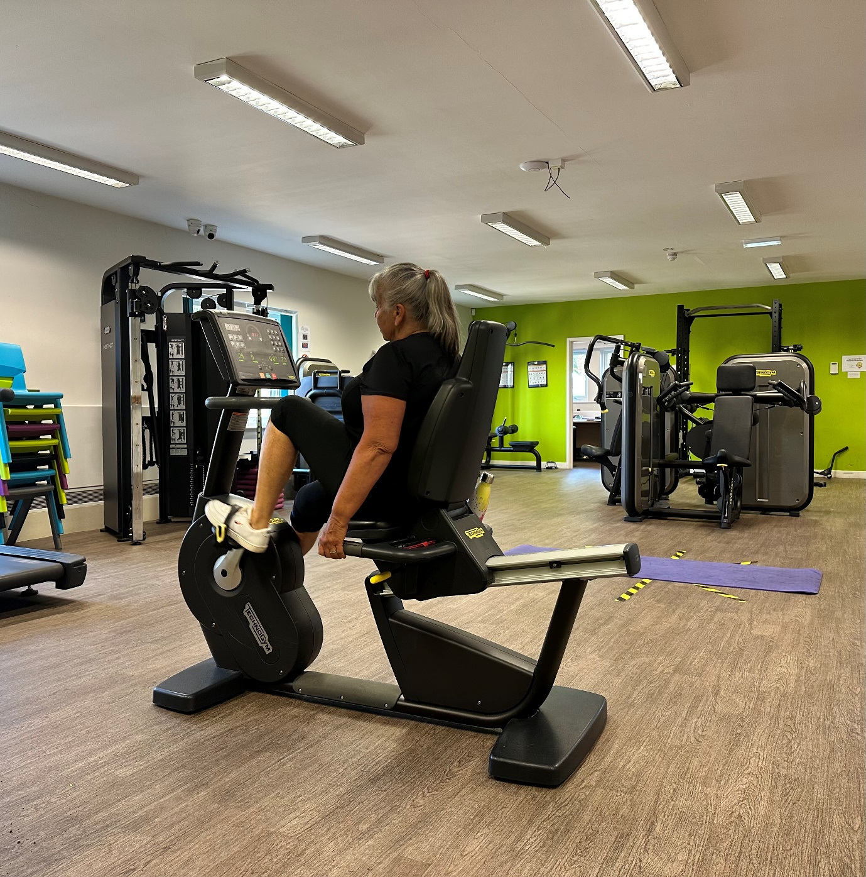

Thank you to Paul Jennings and Helen Fisher at Botcherby Community Centre for completing this project to improve the health and wellbeing of the attendees.
You can contact the team:
Botcherby Community Centre, Carlisle, CA1 2UE
Email: info@botcherbycc.co.uk
Tel: 01228 596 992

Or For further information on this project please contact:
Anna Larden Project Officer for Eden, Carlisle and South Lakeland Localities
| Active Cumbria | Public Health & Communities | Cumberland Council (hosted)
m: 07785 637431
e: Anna.Larden@cumberland.gov.uk
www.activecumbria.org.uk

Supporting Documentation:

- Healthy U Exercise on Referral Eligibility Criteria

- Healthy U Exercise on Referral Individual Assessment Data Key 1

