Dear Richard
Thank you for completing the Safeguarding Adults in Sport Framework.
I am pleased to let you know that your recent submission has been assessed and has received an overall rating of ‘met’. This means that Active Cumbria provided evidence of meeting the essential requirements of all the framework criteria.
You can access your detailed feedback on the framework portal. It is available to view if you log back into the Framework submission portal.
https://portal.anncrafttrust.org/login
As you have received a rating of ‘met’ we are pleased to offer you the opportunity to use the Safeguarding Adults in Sport Framework logos on your organisation’s website, leaflets and documents etc to demonstrate your commitment to safeguarding adults.
We encourage you to continue to develop and embed your work in safeguarding adults and invite you to resubmit to the framework in two years’ time when we look forward to seeing the progress on your action plan.
In the meantime, if you have any questions or require any support regarding putting your plan into action please do not hesitate to contact the ACT team.
Kind regards
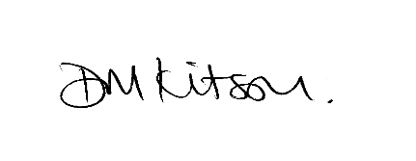
Dr Deborah Kitson
CEO

