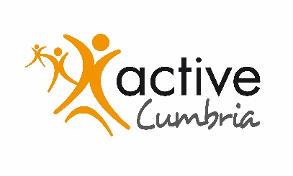
Active Cumbria
Reserves Policy Statement

1. Process

The Active Cumbria Advisory Board Audit Committee, at their meeting on 18 May 2018 discussed in detail the development of a Reserves Policy. A series of recommendations were proposed, which were considered by the Active Cumbria Advisory Board at their meeting on 31 August 2018.

2. Policy

The Advisory Board, at their meeting on 31 August 2018 agreed the following, which form the basis of the Reserves Policy.

- A figure of £100k winding up contribution be regarded as committed reserves year on year. This figure has been revisited and agreed with accountable body Cumbria County Council in May 2021.
- The level of uncommitted reserves be no lower than £300k, equating to approximately 6 months operating costs.
- Additional uncommitted reserves be deployed over the period to March 2027, agreed year on year, to enhance the delivery of the 5 Year Plan.
- Delegated authority be given to Senior Managers to deploy the surplus in line with the outcomes of the 5 year plan, with regular progress reports back to the Advisory Board.
- As part of the on-going Local Government Review process and transition to a new accountable body, all reserves be identified and earmarked as Active Cumbria reserves and novated to the new accountable body in full at the appropriate time.

3. Review

This Policy will be reviewed by the Audit Committee on an annual basis at their October meeting, with recommendations made to the Advisory Board for consideration as appropriate.

Document Review
Revision | Date Reviewed | Next Review | Prepared | Approved
Rev00 | 08/18 | 11/19 | RJ | Advisory Board
Rev01 | 11/19 | 11/20 | RJ | Advisory Board
Rev02 | 05/21 | 11/22 | RJ | Advisory Board

