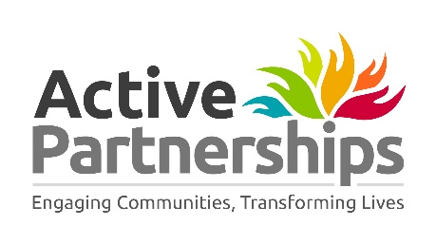

Active Partnerships Statement of Commitment: March 2021
Active Partnerships commitment to tackling racism and racial inequality
Active Partnerships are committed to being anti-racist organisations and proactively tackling the racial inequalities that prevent or discourage people from leading active lives and enjoying the benefits of sport and physical activity, whether as participants, volunteers or by working in the sector.
Tackling inequalities has always been at the heart of the work of Active Partnerships. But when the shocking death of George Floyd caught on video in the US last summer sparked protests and a national debate, we recognised we must do much more to address racism and racial inequalities within sport and physical activity.
We are working together as a network, along with our partners, communities, staff, Boards and external advisors, building our knowledge and understanding of the causes, incidents and impact of racial inequality in our sector, building a long-term commitment and identifying priorities for action to make a sustained and meaningful difference.
Whilst we are small organisations, we recognise the reach and influence we can have through our whole system approach to tackling inactivity and by building anti-racist practice into everything we do. But this requires us to lead by example, recognising our weaknesses, with individual and collective commitment to taking action to become truly inclusive, anti-racist organisations.
Each Active Partnership will have its own plan along with local partners and communities and collectively we will:
Be open and responsible | Recognising our starting point and embracing our personal and organisational responsibility, we will set objectives that we will be accountable for and will reflect on and publish our own progress in positively moving the dial on inequality.
Be strong allies | Leading by example as anti-racist allies, we will ‘come out of the stands’ to challenge racism and racial inequality wherever we see it. Reinforced through our governance and with recruitment processes to ensure we become more representative of the communities we serve. Utilising our communication channels and ensuring we use appropriate, specific language and inclusive imagery.
Create systemic change | Using our insight, reach and influence across multiple sectors, to identify, challenge and change the systemic factors holding current racial inequalities in place that negatively affect levels of physical activity.
Enable communities | Working proactively with communities with high proportions of ethnically diverse groups to create community led, asset based approaches to tackling inactivity and involve communities
Develop the workforce | Creating a more ethnically diverse physical activity workforce, through targeted recruitment, training and development along with progression pathways into and through the sector.
Deliver inclusively | Utilising all our delivery, interventions, funding and resources across all our target audiences, to create new opportunities, build our insight and evidence, to increase activity levels of ethnically diverse communities.

Success measures will include improved representation in our teams, Boards and wider workforce, and ultimately by working collaboratively we will increase levels of activity amongst ethnically diverse communities.
We will continue our journey, listening and learning, supporting each other, monitoring the effectiveness of this work and ensuring we maintain momentum, holding ourselves and each other to account for the commitment we are making.
The work will form one part of our wider equality, diversity and inclusion strategies to tackle all inequalities and ensure those who can benefit most are supported to become more active.

