**Tohoku**

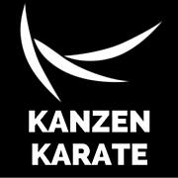 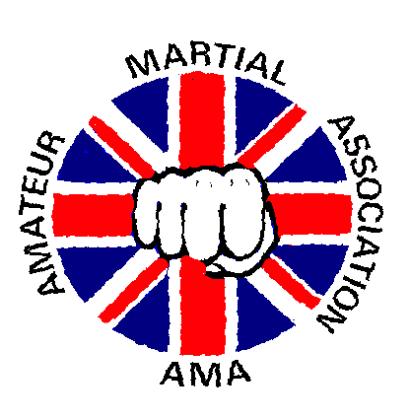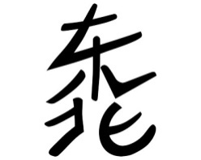

**Karate Club**

**Breakfast Club/After Schools Club**

An eight-week course of one session per week:

* Basic punches, blocks and kicks, creating strength, flexibility, balance and coordination.
* Partner work, encouraging friendship, support and teamwork.
* Pad work, developing accuracy, reflexes and technique.
* Karate related games, keeping the activity fun and engaging.
* Grading, to show progress throughout the course (records are kept for each grading to show progress).

**School Lessons - Karate**

I am a qualified Primary teacher with more than 15 years experience and offer the following:

* Introduce karate into the PE curriculum. I can produce lesson plans, progression records (no grading required) and staff training (twilight).
* Extra curriculum activity:
  + One off lessons for each class.
  + Termly lessons for each class.
* Free taster sessions. Arranged over a full day where each session is for 30 minutes per 20 children or each class. This is for every child year 1-6.
* Free taster sessions. Arranged during a PE lesson where each session is for 45 minutes. For one class or each class over time.
* Free taster sessions. Arranged at breakfast/after school clubs where each session is for 45 minutes. For up to 20 children.
* Duke of Edinburgh Awards. I have signed some off for students at my club in the past.
* Other educational awards.

**School Lessons - General**

* Supply cover for PPA.
* Supply cover for sickness and professional development.

**Tohoku**

 

**Karate Club**

Dear Sir/Madam

My name is Christine Pullan and I have recently moved into the area and am seeking to develop karate lessons in local schools. I currently work with Yanwath, Calthwaite and Beaconside Schools doing breakfast and after schools clubs. I am also teaching taster sessions for Skelton School.

I have been teaching karate for over 40 years. I have competed and continue to coach at international level, I’m ex-world and European champion and have taught adults and children, many to World and European Championship level. I retain a club in the North East, am a director with a martial arts organisation (the Amateur Martial Association), which is one of the largest in the U.K. and am technical officer of a large karate club in Scotland, Kanzen.

**Progression within karate**

The belt system was introduced into karate to show progression in schools when they introduced it into the school curriculum.

The grade structure below shows the grades that can be obtained when 10-12 lessons (or one term) have been achieved between each grade.

Image result for Karate belts Image result for karate white and orange belt Related image Related image  

White White/Orange Orange White/Red Red White/Yellow

 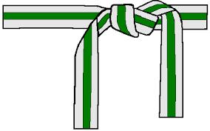 Image result for karate green belt 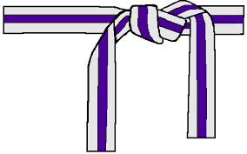  

Yellow White/Green Green White/Purple Purple Purple/White

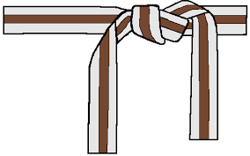 Image result for karate brown and white belt 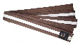 Image result for karate brown and white belt 

White/Brown Brown Brown/White Brown/2 whites Black 1st Dan

Christine Pullan 8th Dan

Kanzen Karate England