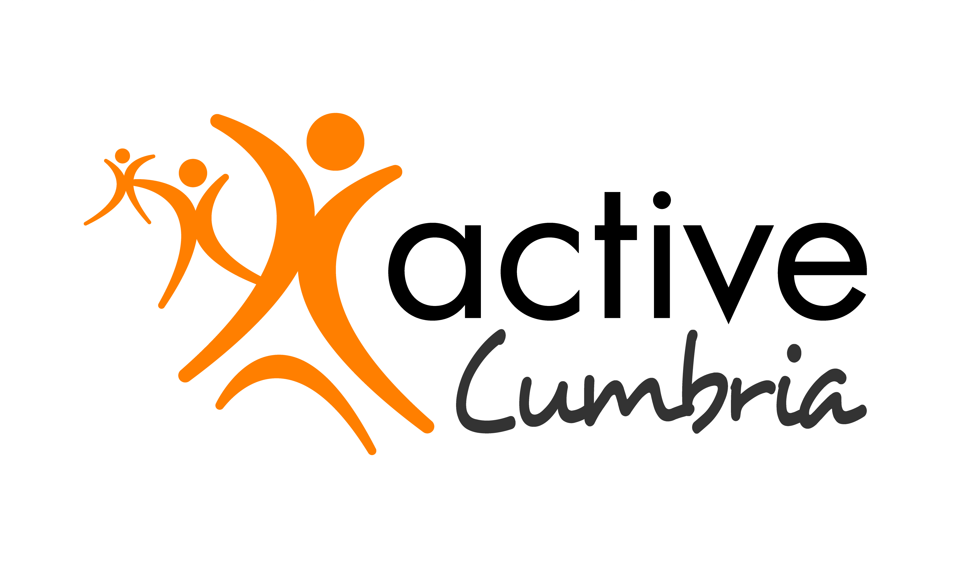

Advisory Board Member Recruitment Pack

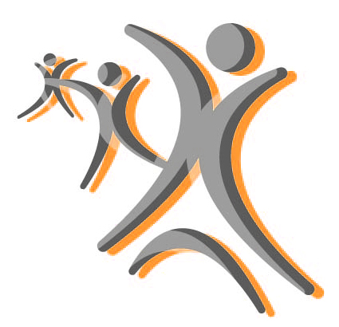

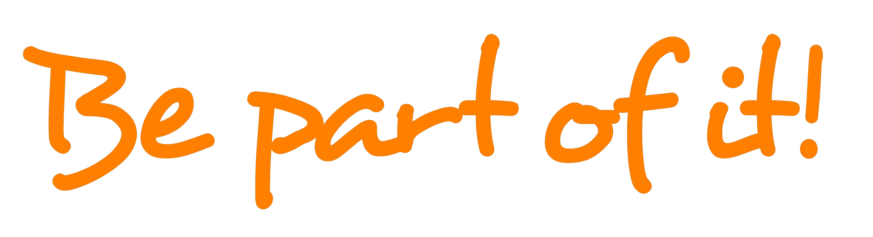

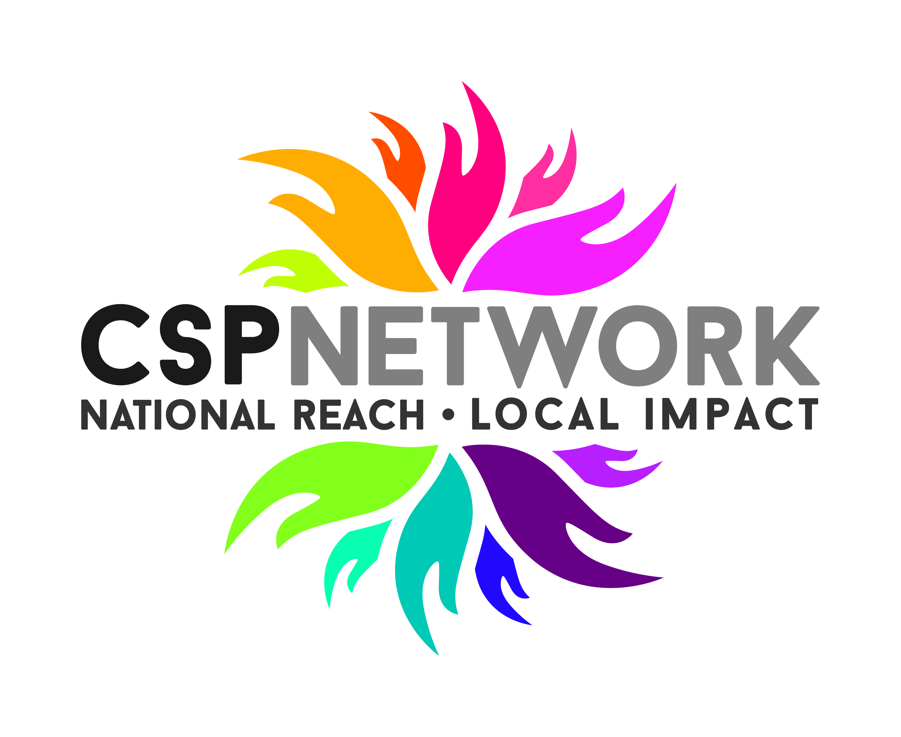
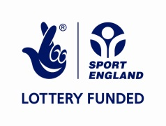
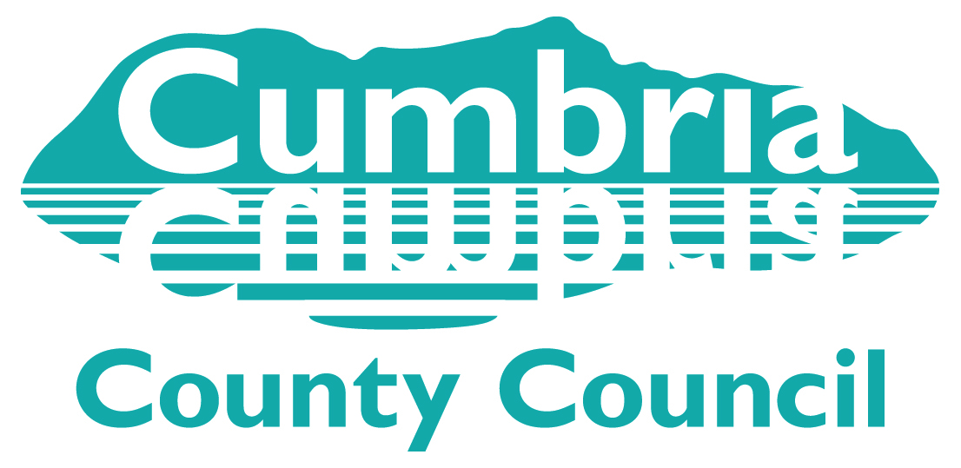

About Active Cumbria

Active Cumbria is the county sports partnership for Cumbria, and is one of 43 such organisations in existence across the whole of England. As a ‘not for profit’ organisation, hosted within Cumbria County Council since our inception in 1999, we have a strong track record of success in the delivery of national services and programmes on behalf of our principal funder Sport England.

Through the provision of leadership, expertise, insight and connectivity, we also continue to support many local organisations to develop services to achieve a wide range of outcomes through increasing participation in physical activity and sport in communities across Cumbria.

We believe that physical activity and sport have a major role to play in improving the health and wellbeing of residents of Cumbria. There is also a growing evidence base around the benefits physical activity can play in supporting the achievement of a range of wider community outcomes. These include the following: -

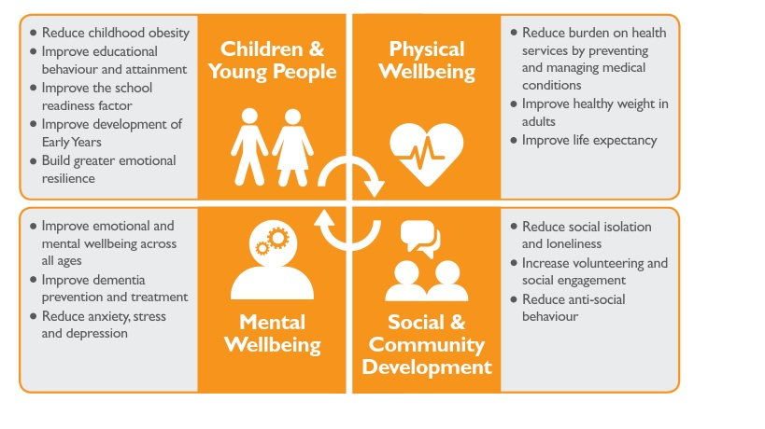
Our role is to provide leadership and expertise for and on behalf of the physical activity and sport sector across Cumbria, we facilitate and broker collaboration and a wide range of relationships, and also advocate the benefits of a physically active lifestyle. We have a deep understanding of our people and communities, and create and share insight and good practice across a range of platforms.

We have a clear role to play in helping to land the ambitions of Sport England’s ‘Towards an Active Nation’ strategy here in Cumbria, through the delivery of our primary role and national funded programme work.

We will also continue to work with local and national partners to design and develop innovative products and services which seek to reduce levels of inactivity within communities in Cumbria.

Further details about our organisation and work can be found here

About the Advisory Board

As an organisation which receives funding through National Lottery and other public sources, we are committed to ensuring we have in place the highest possible standards of governance. We have recently received confirmation from Sport England that we are compliant with tier 3 of the Governance Code for Sport, and we are committed to continuing to meet these standards on an on-going basis.

We are committed to encouraging equality and diversity among our membership, and eliminating unlawful discrimination. The aim is for our Advisory Board to be truly representative of our population and for each member to feel respected and able to give their best. As such, we encourage applications to join the Advisory Board from women, LGBT people, members of black, Asian and minority ethnic groups, as well as people living with a disability.

Our Advisory Board, which is made up of 10 independent, skills based representatives, who collectively contribute to the following over-riding functions: -

- Ensure clarity of vision, values and strategic direction for Active Cumbria activities;
- Provide oversight, input and challenge;
- Actively promote and further the work of Active Cumbria.

Specific accountabilities of the Advisory Board include the following: -

- Agreeing the strategic direction of Active Cumbria;
- Monitoring the achievement of key targets and outcomes as articulated in the 3 Year Plan and Annual Service Plan, providing support and challenge as appropriate;
- Supporting the continuous improvement of Active Cumbria through ‘championing’ a range of work-strands including but not limited to: -
  - Governance
  - Finance
  - Marketing & Communications
  - Safeguarding
  - Equality & Diversity
  - Risk Management
- Provide influence, and advocacy for the work of Active Cumbria on a local, regional and national footprint, drawing on individual member’s expertise and networks to further the aims of the organisation.

Whilst the Advisory Board take the strategic lead on the above, the day to day management of Active Cumbria is not an Advisory Board function, and is carried out by the staff employed through Cumbria County Council.

Person Specification

We are currently seeking a new Advisory Board member who will provide skill, energy, and enthusiasm. We are keen to ensure our Advisory Board reflects the diversity of our population, and as such, we are especially keen to hear from women, LBGT people, members of black, Asian and minority ethnic groups, as well as from people living with a disability.

The following provides more detail on the types of experiences, skills and qualities we are looking for in our new Advisory Board member, as well as setting out more information on the specific duties involved in the role.

Desirable Experience

Members will be able to demonstrate experience in one or more of the following areas.
- Experience of strategic planning, delivery and review;
- Experience of financial planning and good governance standards;
- Experience of marketing, public relations and working with the media;
- Experience of using data and information to create meaningful insight.

Knowledge and Skills

Members will be able to demonstrate knowledge and skills in the following areas.
- Understanding of partnership working;
- Ability to build constructive relationships;
- Ability to motivate and inspire others;
- Ability and willingness to act as an advocate for physical activity to a broad audience;
- Understanding and commitment to equal opportunities and valuing diversity;

Personal Qualities

- Public respect
- Passion for the benefits derived through physical activity
- Independence
- Objectivity
- Discretion

Specific Duties

- Contribute to the effective and efficient operation of the Advisory Board, which meets on 4 occasions each year, and attend other events as required from time to time;
- Contribute to effective relationships with other Advisory Board members and staff;
- Meet with Senior Managers or other staff as required to discuss significant issues and plan;
- Work closely with other members to ensure effective discharge of their roles and responsibilities;
- Operate in accordance with the relevant codes of conduct for sports organisations in the UK;
- Actively participates in the effective development, maintenance and ongoing review of annual budgets and the 3 year plan;
- Support, as appropriate, Advisory Board Sub-Groups, operating under agreed Terms of Reference;
- Contribute to the provision of an appropriate balance of motivation and challenge to Senior Managers and staff across the organisation.

How to Apply

If you wish to apply to join the Active Cumbria Advisory Board please supply the following: -
- A detailed CV setting out your career history, with responsibilities and achievements;
- A covering letter highlighting your suitability for the role;
- A completed Active Cumbria Diversity Form.

Further details on the Advisory Board and the work of Active Cumbria can be found here

To apply please send your CV, cover letter and diversity monitoring form to: -richard.johnston@cumbria.gov.uk

If you would like to have an informal discussion regarding this opportunity please contact Richard Johnston, Senior Manager (Operations) on 07973811204.

