SportStart

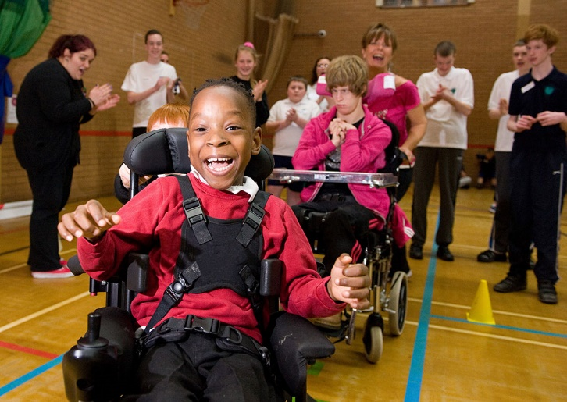

PLAY, PARTICIPATE, ENJOY

Welcome
Cerebral Palsy Sport is the country’s leading National Disability Sports Organisation (NDSO) supporting people with cerebral palsy and associated physical disabilities to reach their sporting potential by putting people with cerebral palsy at the heart of everything we do.

Our aim is to raise aspirations, promote inclusion and support people with cerebral palsy and other physical disabilities to play, participate and enjoy sport and active recreation.

We believe that every person with cerebral palsy and physical disabilities has the right to participate in a sport of their choice that fits their individual needs and ability. Our SportStart programme is the first step in help them in achieving this goal.

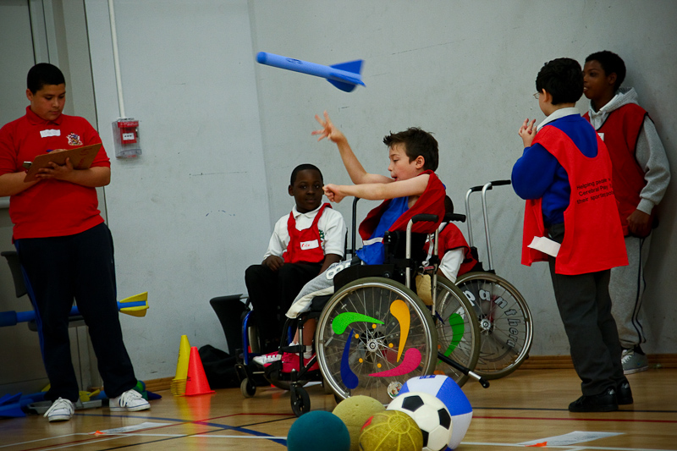

What is SportStart?
Cerebral Palsy Sport SportStart days offer a great opportunity for children with cerebral palsy and other physical disabilities to play and enjoy sport. The day aims to raise their self-esteem and help them lead healthier, happier and more independent lives by giving them the chance to try new sport and activities and then go on to regularly participate.
For each SportStart day, CP Sport work with local clubs and organisations to deliver a range of sporting opportunities. Often giving participants the first opportunity to try a specific sport and ensuring they leave with information on how to continue participating outside of school.
These inspiring inclusive days allow the participants to enjoy playing sport with others who have a similar impairment in a fun safe environment. The participants have the opportunity to try a range of sports and activities either as a first step into the sport or develop their skills.
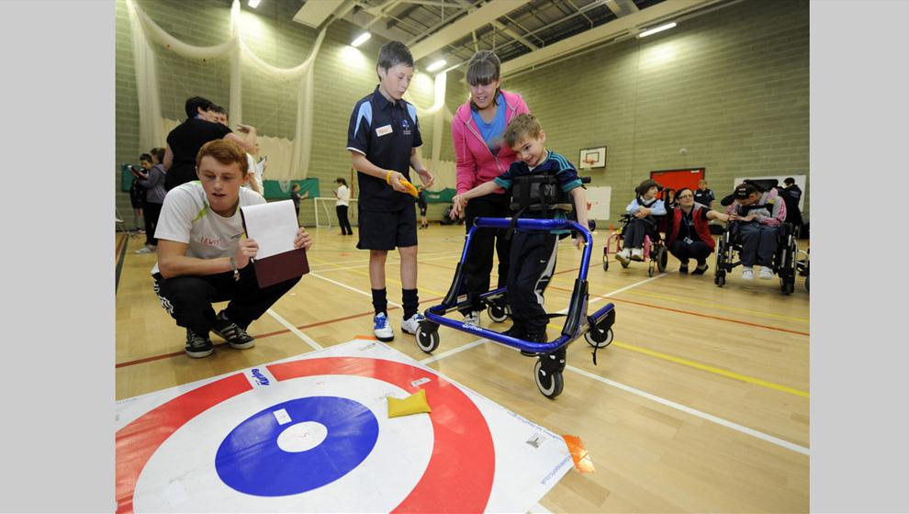

Who is Involved?
Participants
SportStart Days are designed for people aged between 5-21 years old, with cerebral palsy and physical disabilities. Although all of the activities will be physical disability focused, children with learning and sensory impairments would be welcome to take part in all of the activities. The idea is for the participants to try new sports, meet the coaches and volunteers involved and hopefully join new clubs outside of school.
Parents, Teachers & Support Staff
As well as children; parents, carers, teachers, and teaching assistants are strongly encouraged to get involved in the activities. By doing this teachers and support staff can gain information about adapted sports that may help to support the students in the school sport environment. This information will also be helpful for parents in finding out about opportunities that exist outside of school. The aim is to provide a section of the day focussed at Teachers and TA’s on how to best adapt their PE lesson to include everyone.
Coaches
During SportStart days experienced coaches from local clubs introduce the participants to a variety of adapted, disability sports appropriate to their age and ability. This is also a useful opportunity for clubs to promote themselves and attract new members. It is our hope that the students will enjoy some of the sports that they play and want to take part in the sport regularly outside of school
Volunteer Students
Students will be invited (from Universities, Colleges and Secondary Schools) to further develop their knowledge of inclusive sport. Training can be provided beforehand to a group of volunteers for them to then deliver on the day.
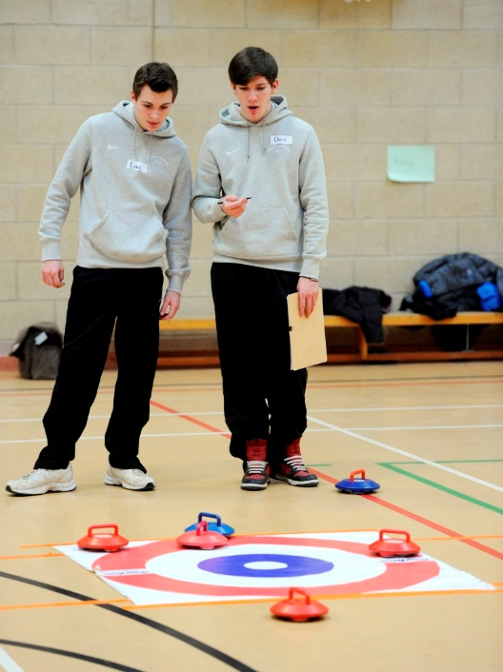

What to expect at a SportStart Day
The SportStart day will consist of a number of different activities. The activities will depend on what is on offer in the local community to ensure positive links are made for lifelong participation.

Sports can include:
- Bowls
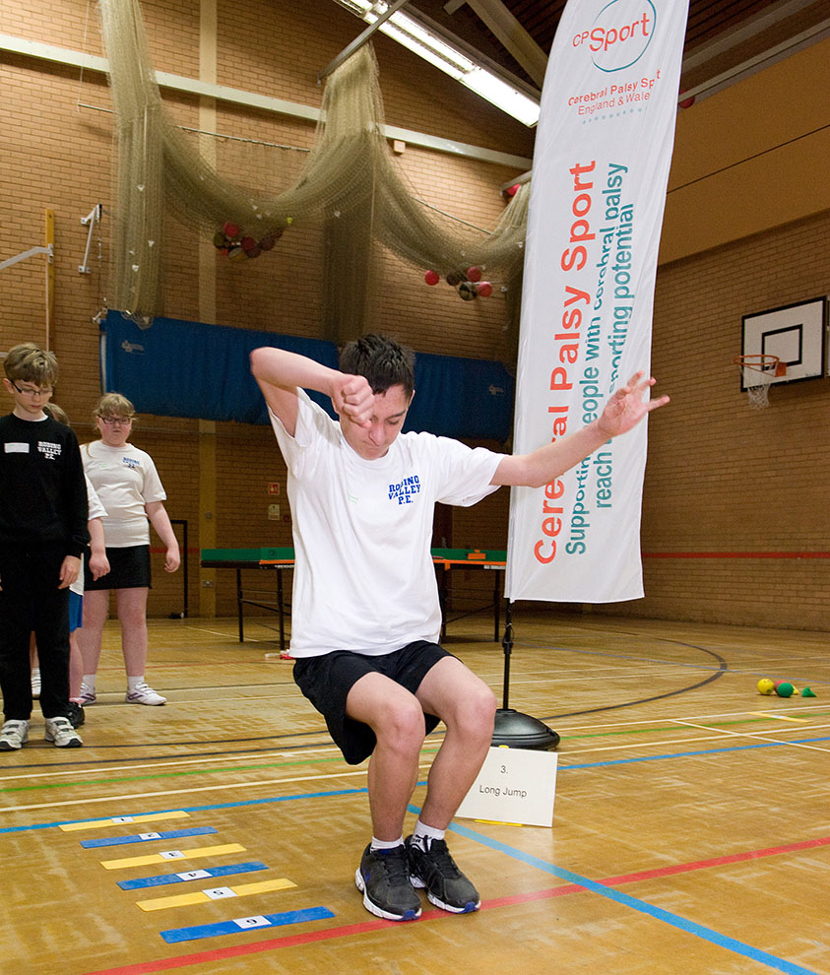
- Boccia
- Table Cricket
- Polybat
- Football and Frame Football
- Athletics
- RaceRunning
- PE Inclusion games
- Seated Volley ball
- Tennis

A Typical SportStart Day

10.00am: Registration and Introduction
10.30am: Pupils are divided into teams and sent to first activity
10.45am: Activity 1
11.30am: Activity 2
12.15pm: Lunch (details on ‘bring your own’ or ‘lunch is provided’ will be on the event information.
1.15pm: Activity 3
2.00pm: Activity 4
2.45pm: De-brief, certificates and time to talk to the local clubs and get information from them.
3.15pm: Back to school! Or home time.

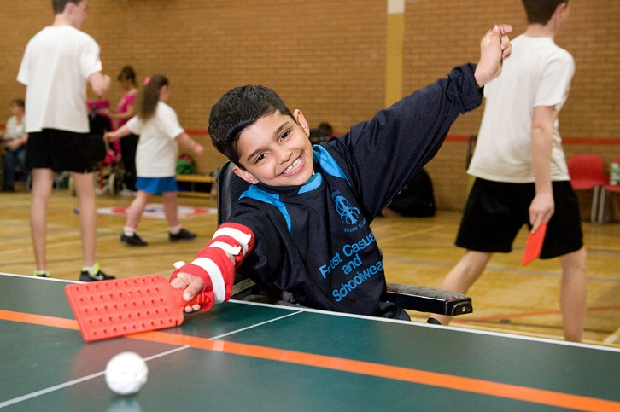

What are the Benefits of SportStart?
SportStart days positively impact on outcomes for the schools sport premium fund. The days will allow your school to take part in quality activities that can be transferred to PE and school Sport
- Provide schools with information, knowledge and resources for adapted sports and working with people with CP and physical disabilities in school sport.
- Opportunity to realise sporting and personal potential
- Personal development raising aspirations and self-belief of both participants and teaching staff
- Opportunities to build friendships and develop social skills
- Enhance physical and emotional wellbeing.
- Volunteers gain valuable experience and enhance their skills.
- Each teacher and TA that get involved will receive a certificate to say they have attended a CP Sport SportStart training day.
- On the day, each participant will receive a participation certificate
- Schools will be provided with contacts with local clubs to ensure there is a pathway for pupils to continued participating
- Promotion of inclusion rather than exclusion.
- Opportunity for those who may be least active to take up sport

Overall each SportStart day is a fun, enjoyable day that often provides the first opportunity for someone with a physical disability to try a sport as well as key learning for teachers/support staff.

How do we get involved?
I want an event in my area
Get in touch with the contact details below, we would be delighted to discuss the options of hosting an event near you. Our charity is keen to get as many participants taking part in SportStart days as possible.
How do we apply to attend a SportStart event?
The events are first come first served so move fast to avoid disappointment. If you would like to register your school or individual into a SportStart day, please visit http://www.cpsport.org/sports/sportstart/ and navigate to the events info. Here you will find registration forms with payment details.
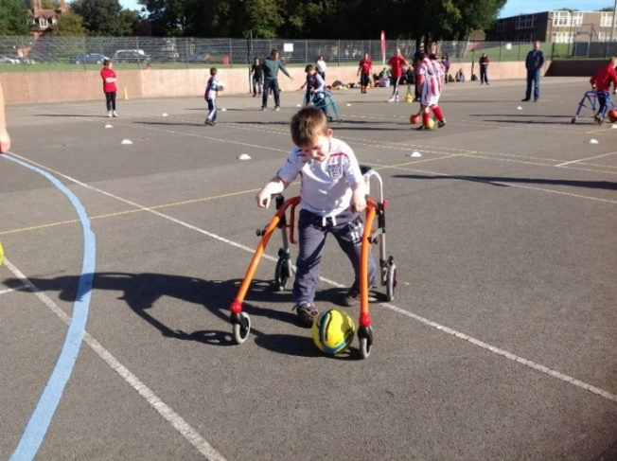
SportStart costs?
A SportStart event costs £1300.
If there is an appropriate venue provided free of charge this cost will decrease.
Costs include all administration work before during and after event, equipment, medals and certificates, coaching fees and travel expenses of CP Staff and Volunteers.

What happens afterwards?
Keeping in touch
At CP Sport, we endeavour to create sustainability for our young people from every event we deliver.
We will ensure CP Sport are updating school contacts (CSPs and SGOs etc) with events and information relevant to your area.
Keep in touch with us too! Please don’t hesitate to send any relevant information you would like distributing or advertising and we will discuss our options.
Sports Clubs and Links
On the day, we will suggest ways of setting up links between local clubs and schools that are sustainable. Taster sessions or after school clubs for example.
If participants sign up, they can invite their friends and encourage other school members to join their club.

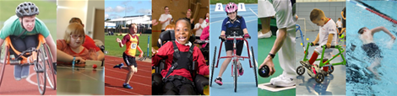

Cerebral Palsy Sport and what we can offer
Cerebral Palsy Sport deliver various training days and events throughout the year. You can find a list of our events on our website here:
http://www.cpsport.org/events/
Our main sport programmes are:
Football Swimming Athletics and RaceRunning
Table Cricket SportStart Touch Golf …

Contact for more information
jennifer.basford@cpsport.org
0115 925 7027
07519 809024
If you require any further information or support please contact:

Cerebral Palsy Sport
Unit 5, Heathcoat Building,
Nottingham Science & Technology Park
University Boulevard
Nottingham
NG7 2QJ

T: 0115 925 7027
E: info@cpsport.org
Facebook: https://www.facebook.com/CerebralPalsySport/
@CerebralPalsySport
Twitter: https://twitter.com/CP_Sport
@CP_Sport

